## Task1

**OUTPUT:-**

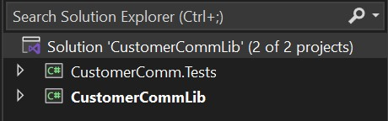

Code For MailSender.cs

// MailSender.cs

using System.Net;

using System.Net.Mail;

namespace CustomerCommLib

{

public interface IMailSender

{

bool SendMail(string toAddress, string message);

}

public class MailSender : IMailSender

{

public bool SendMail(string toAddress, string message)

{

MailMessage mail = new MailMessage();

SmtpClient SmtpServer = new SmtpClient("smtp.gmail.com");

mail.From = new MailAddress("your_email_address@gmail.com");

mail.To.Add(toAddress);

mail.Subject = "Test Mail";

mail.Body = message;

SmtpServer.Port = 587;

SmtpServer.Credentials = new NetworkCredential("username", "password");

SmtpServer.EnableSsl = true;

SmtpServer.Send(mail);

return true;

}

}

}

According to questionInclude the following namespaces with ‘using’ directive.

* System.Net
* System.Net.Mail

Code for CustomerComm.cs

namespace CustomerCommLib

{

public class CustomerComm

{

private readonly IMailSender _mailSender;

private readonly ICustomerRepository _repository;

public CustomerComm(IMailSender mailSender, ICustomerRepository repository)

{

_mailSender = mailSender;

_repository = repository;

}

public bool SendMailToCustomer(int customerId)

{

string email = _repository.GetCustomerEmail(customerId);

return _mailSender.SendMail(email, "Some Message");

}

}

}

Code for CustomerRepository.cs

namespace CustomerCommLib

{

public class CustomerRepository : ICustomerRepository

{

public string GetCustomerEmail(int customerId)

{

// Simulate database logic

return "cust123@abc.com";

}

}

}

Code for ICustomerRepository.cs

namespace CustomerCommLib

{

public interface ICustomerRepository

{

string GetCustomerEmail(int customerId);

}

}

Code for FileProcessor.cs

namespace CustomerCommLib

{

public class FileProcessor

{

private readonly IFileReader _fileReader;

public FileProcessor(IFileReader fileReader)

{

_fileReader = fileReader;

}

public string GetFileContent(string path)

{

return _fileReader.ReadFile(path);

}

}

}

Code for FileReader.cs

using System.IO;

namespace CustomerCommLib

{

public class FileReader : IFileReader

{

public string ReadFile(string path)

{

return File.ReadAllText(path);

}

}

}

Code for IFileReader.cs

namespace CustomerCommLib

{

public interface IFileReader

{

string ReadFile(string path);

}

}

## Task2

OUTPUT:-



**2.**

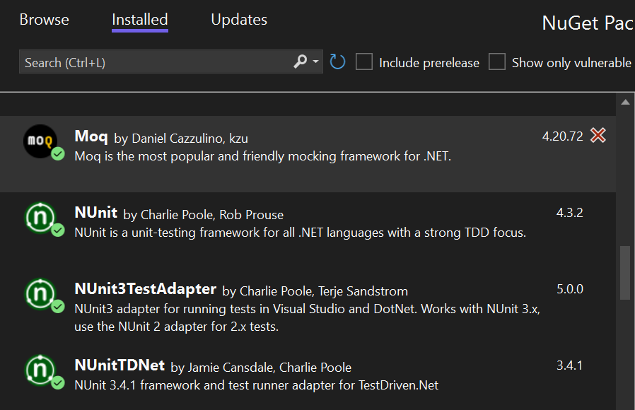

In CustomerComm.Tests project

Code for CustomerCommTests.cs

using NUnit.Framework;

using Moq;

using CustomerCommLib;

namespace CustomerComm.Tests

{

[TestFixture]

public class CustomerCommTests

{

private Mock<IMailSender> _mockMailSender;

private Mock<ICustomerRepository> _mockRepository;

private CustomerCommLib.CustomerComm _customerComm;

[OneTimeSetUp]

public void Init()

{

_mockMailSender = new Mock<IMailSender>();

_mockRepository = new Mock<ICustomerRepository>();

_mockMailSender

.Setup(x => x.SendMail(It.IsAny<string>(), It.IsAny<string>()))

.Returns(true);

_mockRepository

.Setup(x => x.GetCustomerEmail(It.IsAny<int>()))

.Returns("test@abc.com");

_customerComm = new CustomerCommLib.CustomerComm(_mockMailSender.Object, _mockRepository.Object);

}

[Test]

public void SendMailToCustomer_ShouldReturnTrue_WhenMocked()

{

var result = _customerComm.SendMailToCustomer(123);

NUnit.Framework.Assert.IsTrue(result);

}

}

}

Code for FileProcessorTests.cs

using NUnit.Framework;

using Moq;

using CustomerCommLib;

namespace CustomerComm.Tests

{

[TestFixture]

public class FileProcessorTests

{

private Mock<IFileReader> _mockFileReader;

private FileProcessor _fileProcessor;

[SetUp]

public void Init()

{

_mockFileReader = new Mock<IFileReader>();

_mockFileReader

.Setup(x => x.ReadFile(It.IsAny<string>()))

.Returns("This is mock file content");

_fileProcessor = new FileProcessor(_mockFileReader.Object);

}

[Test]

public void GetFileContent_ShouldReturnMockedContent()

{

var result = _fileProcessor.GetFileContent("fake_path.txt");

Assert.AreEqual("This is mock file content", result);

}

}

}

Full Structure of Created File.

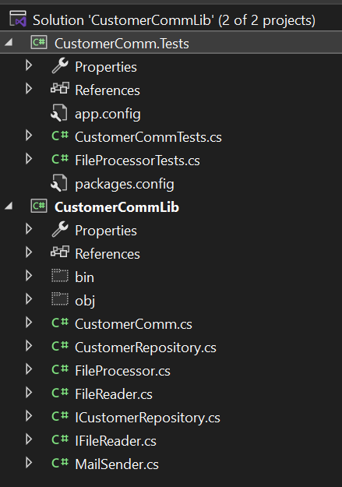

Project

OUTPUT:-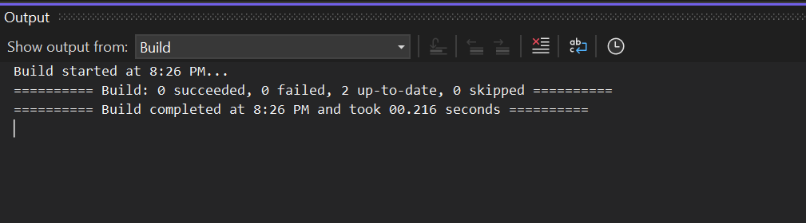

OUTPUT:-